Zapisani so le tisti elementi, ki so na sliki oziroma sceni novi.

Scena 1:
Ozadje in mravlje iz programa Story Jumper.
Čebele: https://pixabay.com/vectors/honeybee-bee-flying-fly-insect-24633/
Lisica: https://pixabay.com/vectors/fuchs-fox-red-fox-creature-mammal-2530031/
Štorklja: https://pixabay.com/vectors/stork-bird-fly-wings-2023318/
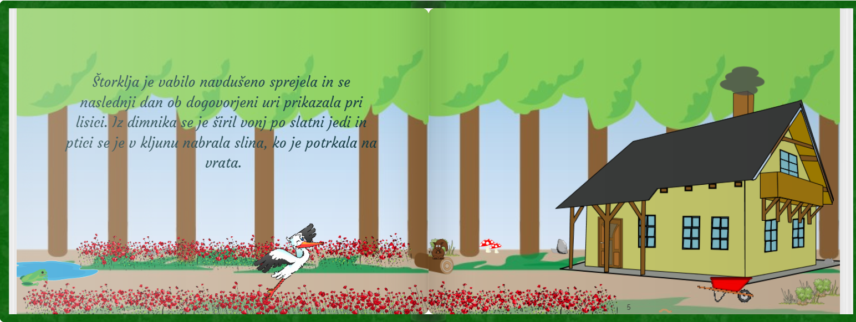
Scena 2:
Rožice: https://pixabay.com/illustrations/flowers-red-nature-vector-2755297/
Gobe: https://pixabay.com/vectors/mushroom-red-cartoons-fungi-23893/
Samokolnica: https://pixabay.com/vectors/wheelbarrow-tools-gardening-red-2029732/
Trava: https://pixabay.com/vectors/border-bush-garden-grass-green-1294868/
Ozadje, dim, hiša, kamen, veverica, hlod, žaba, mlaka so iz programa Story Jumper.
Scena 3:
Ozadje, okvir s sliko, stola, preproga, jabolki, jagoda, svetilka, kozarec s pijačo, stenska ura, kavč, krožnik z juho in omarica so iz programa Story Jumper.
Jedilna miza: https://pixabay.com/vectors/table-wooden-desk-furniture-23627/
Spodnji krožnik: https://pixabay.com/vectors/plate-porcelain-tableware-dishes-161124/
Štorklja preoblikovana.
Scena 4:
Ozadje, gobe, miši in zajec so iz programa Story Jumper.
Štorklja preoblikovana.
Scena 5:
Vse iz programa (metulji, rože, vzpenjavka, trstičje, goba, deteljice, drevesa, sonce …)
Lisica preoblikovana.
Scena 6:
Stenska ura: https://pixabay.com/vectors/clock-cuckoo-clock-pendulum-weight-1745702/
Zavesa: https://pixabay.com/vectors/curtains-drapery-fabric-textile-42859/ (preoblikovana oz. pobarvana)
Ostalo vse iz programa Story Jumper (visoki posodi, olive, kruh, sladica, sir, sveče, lestenec).
Scena 8:
Vse ponovljeno.

